## **Lab 04**

## **Task 01**

1. Write a python program on the given dataset and implement linear regression to check best fit line.

<https://www.kaggle.com/datasets/quantbruce/real-estate-price-prediction>

## **Task 02**

1. Write a linear regression python program to analyze following dataset and give the result

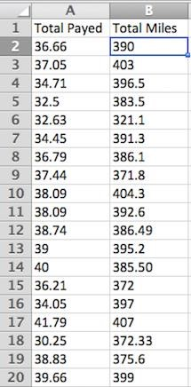

## **Task 03**

1. Write a python program on the given dataset and implement KNN for multiple labels and plot your result.

<https://www.kaggle.com/code/mjamilmoughal/k-nearest-neighbor-classifier-to-predict-fruits/data>

## **Task 04**

1. Implement KNN without using Sklearn Library

**Solutions attached!!**